

Bachelor of Computer Applications (BCA) Programme

Minor Project Report

BCA Sem V

AY 2023-24

*Project Title: CROMA STORE*

*by*

|  |  |  |
| --- | --- | --- |
| Exam No. | Roll No. | Name of Student |
| 6377 | 163 | SONI ANANT R. |

**Project Guide by :**

Prof. Vandana Prajapati

**Acknowledgement**

The success and final outcome of this project required a lot of guidance and assistance from many people and we are extremely fortunate to have got this. the completion of our minor project

work. Whatever we have done is only due to such guidance and assistance.

We would not forget to thank I/C Principal Dr. Aditi Bhatt, IQAC coordinator and trust representative Dr .Vaibhav Desai, Head of BCA Department Dr. Vimal Vaiwala and Minor Project guide Prof. Vandana Prajapati and all other Assistant professors of SDJ International College, who took keen interest on our project work and guided us all along, till the completion of our project work by providing all the necessary information for developing a good system.

We are extremely grateful to her for providing such a nice support and guidance though she had busy schedule the college dealings.

We are thankful and fortunate enough to get support and guidance from all Teaching staffs of Bachelor of Computer Application Department which helped us in successfully completing our project work. Also, we would like to extend our sinceto all the non-teaching staff of Bachelor of Computer Application Department for their timely support.

SONI ANANT R. **(6377)**

I N D E X

|  |  |  |
| --- | --- | --- |
| **Sr. No** | **Description** | **Page No.** |
| 1 | Introduction | 2 |
|  | 1.1 Project description | 2 |
|  | 1.2 Project Profile | 2 |
| 2 | Environment Description | 3 |
|  | 2.1 Hardware and Software Requirements | 3 |
|  | 2.2 Technologies Used | 3 |
| 3 | System Analysis and Planning | 6 |
|  | 3.1 Existing System and its Drawbacks | 6 |
|  | 3.2 Feasibility Study | 6 |
|  | 3.3 Requirement Gathering and Analysis | 8 |
| 4 | Proposed System | 10 |
|  | 4.1 Scope | 10 |
|  | 4.2 Project modules | 10 |
|  | 4.3 Module vise objectives/functionalities Constraints | 10 |
| 5 | Detail Planning | 12 |
|  | 5.1 Data Flow Diagram / UML | 12 |
|  | 5.2 Process Specification / Activity Flow Diagram | 13 |
|  | 5.3 Data Dictionary | 15 |
|  | 5.4 Entity-Relationship Diagram / Class Diagram | 16 |
| 6 | System Design | 17 |
|  | 6.1 Database Design | 17 |
|  | 6.2 Directory Structure | 18 |
|  | 6.3 Input Design | 19 |
|  | 6.4 Output Design | 24 |
| 7 | Software Testing | 26 |
| 8 | Limitations and Future Scope of Enhancements | 27 |
| 9 | References | 28 |

**Introduction**

**1.1 Project Summary**

Project Name: Croma Store. To expand Croma's retail presence and enhance the customer shopping experience.Opening new Croma stores in strategic locations, updating existing stores, and implementing innovative technologies.A phased approach over the next 2 years.

Increase market products, offer a wide range of consumer electronics, improve customer service, and boost online sales.Focus on product diversification, modern store designs, and omnichannel integration.Incorporate eco-friendly practices and promote responsible consumption.Implement loyalty programs, tech workshops, and personalized recommendations. Strengthen Croma's position in the electronics retail market and drive sustainable growth in sales and customer satisfaction.

**1.2 Project Profile Project Title:**

|  |  |
| --- | --- |
| **Definition** : | Croma Store will Provides a platform for users to buying an electronic products. |
| **Developed For :** | SDJ International College, Vesu, Surat |
| **Project Guide(s):** | Prof. Vandana Prajapati |
| **Front End:** | PHP |
| **Scripting language :** | PHP, CSS, BOOTSTRAP, JAVASCRIPT |
| **Back End :** | Xampp Server |
| **Operating System:** | Microsoft Windows 11 |
| **Tools used for ERD & DFD** | Sublime Text, Visual Studio, Xampp , Chrome |
| **Submitted By** | Soni Anant R. (6377 ) |

**Environment Description**

**2.1 Hardware and Software Requirements**

Online flight booking system requires following technical specifications to run properly and efficiently.

* SERVER SIDE:

• **Hardware Requirements**

Windows 11

MySQL

XAMPP

Bootstrap, CSS, Javascript.

* CLIENT SIDE:

• **Hardware Requirements**

11th Gen Intel(R) Core(TM) i5-1155G7 @ 2.50GHz 2.50 GHz

8.00 GB

• **Soft ware Requirements**

Windows 11

Browsers : Google Chrome.

**2.2 Technologies Used**

**Front End: PHP**

PHP (recursive acronym for PHP: Hypertext Preprocessor) is a widely-used open source general-purpose scripting language that is especially suited for web development and can be embedded into HTML.

What distinguishes PHP from something like client-side JavaScript is that the code is executed on the server, generating HTML which is then sent to the client. The client would receive the results of running that script, but would not know what the underlying code was. You can even configure your web server to process all your HTML files with PHP, and then there's really no way that users can tell what you have up your sleeve.

**Back End: MySQL**

MySQL runs on virtually all platforms, including Linux, UNIX, and Windows. Although it can be used in a wide range of applications, MySQL is

most often associated with web-based applications and

online publishing and is an important component of an open

source enterprise stack called LAMP. LAMP is a Web development platform that uses Linux as the operating system, Apache as the Web server, MySQL as the relational database management system and PHP as the object-oriented scripting language.MySQL is an essential part of almost every open source PHP application. Good example for PHP/MySQL-based script are PHPBB.

**XAMPP:**

XAMPP stands for Cross-Platform (X), Apache (A), MySQL (M), PHP

(P) and Perl (P). It is a simple, lightweight Apache distribution that makes it extremely easy for developers to create a local web server for testing purposes. Everything you need to set up a web server - server application (Apache), database (MySQL), and scripting language (PHP) - is included in a simple extractable file. XAMPP is also cross-platform, which means it works equally well on Linux, Mac and Windows.

Since most actual web server deployments use same components

as XAMPP, it makes transitioning from a local test server to a live server is extremely easy as well. XAMPP has four primary components:

• Apache: Apache is the actual web server application that processes and delivers web content to a computer. Apache is the most popular web server online, powering nearly 54% of all websites.

• MySQL: Every web application, howsoever simple or complicated, requires a database for storing collected data. MySQL, which is open source, is the world's most popular database management system. It powers everything from hobbyist websites to professional platforms like WordPress. You can learn how to master PHP with this free MySQL database for beginner's course.

• **PHP**: PHP stands for Hypertext Preprocessor. It is a server-side scripting language that powers some of the most popular websites in the world, including WordPress and Facebook. It is open source, relatively easy to learn, and works perfectly with MySQL, making it a popular choice for web developers.

**Bootstrap**:

Bootstrap is a free and open-source front-end web framework for designing websites and web applications. It contains HTML- and CSS-based design templates for typography, forms, buttons, navigation and other interface components, as well as optional JavaScript extensions.

It aims to ease the development of dynamic website and web

application. Bootstrap is a front end web framework, that is, an interface for the user, unlike the server-side code which resides on the "back end" or server.

Bootstrap provides a set of stylesheets that provide basic style definitions for all key HTML components. These provide a uniform, modern appearance for formatting text, tables and form elements.

• **CSS**:

Cascading Style Sheets (CSS) is a style sheet language used for describing the presentation of a document written in a markup language. Although most often used to set the visual style of web pages and user interfaces written in HTML and XHTML, the language can be applied to any XML document, including plain XML, SVG and XUL, and is applicable to rendering in speech, or on other media.

Along with HTML and JavaScript, CSS is a cornerstone technology used by most websites to create visually engaging webpages, user interfaces for web applications, and user interfaces for many mobile applications. Before CSS, nearly all presentational attributes of HTML documents were contained within the HTML markup. All font colors, background styles, element alignments, borders and sizes had to be explicitly described,

often repeatedly, within the HTML. CSS lets authors move much of

that information to another file, the style sheet, resulting in considerably

simpler HTML.

**JavaScript**:

JavaScript is a high-level, dynamic, untyped, and interpreted programming language. It has been standardized in the ECMAScript language specification. Alongside HTML and CSS, JavaScript is one of the three core technologies of World Wide Web content production; the majority of websites employ it, and all modern Web browsers support it without the need for plug-ins.

JavaScript is prototype-based with first-class functions, making it a multi-paradigm language, supporting object-oriented, imperative, and functional programming styles.

**System Analysis and Planning**

**3.1 Existing System and its Drawbacks**

Croma stores utilize POS systems for processing transactions, managing sales, and accepting various payment methods. Croma likely has an online store integrated with its physical stores to allow customers to browse and purchase products online.Croma may use feedback and survey tools to collect customer opinions and improve services.These systems help in managing relationships with suppliers and tracking product deliveries.

* Daily updates with electronics items with daily new discounts.
* Risk of mismanagement and of data when the project is under development.
* Product Exchange/Returns, Product Protection Plans
* Financing and EMI Options, Customer Assistance
* Tech Workshops and Training
* Product Protection Plans

**3.2 Feasibility Study**

The feasibility of opening a Croma store or expanding an existing one depends on several factors, including market conditions, location, investment capacity, and business strategy. Here are key considerations for assessing the feasibility of a Croma store:

**1. Market Demand:**

Analyze the local or regional market to determine the demand for consumer electronics. Consider factors such as population size, income levels, and technology adoption rates.

**2. Competition:**

Evaluate the level of competition in the area. Consider the presence of other electronics retailers, both online and offline, and assess whether there is room for another player like Croma.

**3. Supply Chain and Inventory Management:**

Develop efficient supply chain and inventory management systems to ensure a steady supply of products and minimize carrying costs.

**4. Marketing and Branding:**

Develop a strong marketing and branding strategy to create awareness and attract customers. Consider digital marketing, traditional advertising, and loyalty programs.

**5. Financial Projections:**

Prepare financial projections, including revenue forecasts, expense estimates, and break-even analysis, to assess the store's profitability potential.

**6. Risk Assessment:**

Identify potential risks and challenges, such as economic fluctuations, supply chain disruptions, and changing consumer preferences, and develop mitigation strategies.

**7. Customer Feedback and Engagement:**

Seek feedback from potential customers and engage with the local community to understand their needs and expectations.

the feasibility of a Croma store project will depend on a thorough market analysis, strategic planning, and a well-executed business plan. Conducting feasibility studies, market research, and financial assessments are essential steps to determine whether opening or expanding a Croma store is a viable and profitable venture in a specific location.

**3.3 Requirement Gathering and Analysis**

Requirements gathering and analysis are crucial steps in the development or enhancement of any system or project, including one for a Croma store. Here's a structured approach to gathering and analyzing requirements for a Croma store project:

**1. Technology Requirements:**

Determine the technology and infrastructure requirements, including POS systems, inventory management software, security systems, and online platforms.

**2. Payment and Checkout:**

- Define the requirements for payment processing, including payment methods accepted and security measures.

**3. Customer Experience:**

- Gather requirements related to customer experience, such as product demonstrations, technical support, and staff training.

**4. Performance and Scalability:**

- Identify performance requirements, including peak customer loads, and scalability needs for future growth.

**5. Review and Validate:**

- Review the requirements with stakeholders to ensure they accurately reflect their needs and expectations.

Other **Requirements**:

• Security • Portability

• Correctness • Efficiency

• Flexibility • Reusability

* **Performance requirements:**

**Response Time :**

Website and mobile app response time should be fast to provide a smooth online shopping experience.

**Transaction Processing :**

The POS system should be capable of handling a high volume of transactions during peak hours without delays or errors.

**Network Reliability :**

Reliable internet connectivity to ensure that POS systems, online sales, and customer communication are uninterrupted.

**Data Security :**

Compliance with data protection regulations, such as GDPR or CCPA.

**Mobile Device Compatibility:**

Ensure that the website and mobile app perform well across various devices and screen sizes.

**Processed System**

**4.1 Scope**

The Croma Store website is an application stored in the user server. The purpose of the website, which are a retail chain specializing in consumer electronics and appliances, can be summarized as follows:

* Retailing Electronics and Appliances
* Transaction Processing
* Checkout Process
* Network Reliability
* Customer Service Response Time
* Mobile Device Compatibility
* Feedback and Improvement

**4.2 Project modules**

* **Point of Sale (POS) Module:**

This module manages the in-store sales transactions, including product scanning, payment processing, and generating receipts.

* **Inventory Management Module:**

Handles the tracking of product inventory, including stock levels, restocking, and inventory reporting.

* **Online Sales Module:**

Manages the online store, including product listings, customer orders, and online payment processing.

* **Marketing and Promotion Module:**

Manages marketing campaigns, promotions, and advertising efforts to attract and retain customers.

**4.3 Module vise objectives/functionalities Constraints**

**1. Point of Sale (POS) Module:**

**Objectives/Functionalities**:

Efficiently process sales transactions, including product scanning and payment.

Generate accurate receipts and invoices.

Manage returns and refunds.

**Constraints**:

Must ensure data security and compliance with payment industry standards (e.g., PCI DSS).

Need for reliable internet connectivity for real-time transaction processing.

**2. Inventory Management Module**:

**Objectives/Functionalities:**

Track inventory levels in real-time.

Automate reordering of products when stock is low.

Provide inventory reporting and analytics.

**Constraints:**

Must handle a diverse range of products with varying lifecycles and storagerequirements.

Need for barcode or RFID scanning systems for accurate inventory tracking.

**3. Online Sales Module:**

**Objectives/Functionalities:**

List products on the online platform.

Allow customers to browse and purchase products online.

Process online payments securely.

**Detail Planning**

**5.1 Data Flow Diagram / UML**

**Context-level:**

**Request for login Request for registration**

Response of login Request to Login

**Admin Croma Store User**

Request of loginResponse of Login

**Response for registration Response for login**

**1st Level (admin) Diagram:**

**Confirm Access response login**

**Log in**

Request access

Request login

Request data

Request data **User**

**Admin guest**

Response data

Response data

Response data

Response registration details

**registration** request data

manage registration

**UML diagram:**

**Admin Croma Store User**

**5.2 Process Specification / Activity Flow Diagram**

**Admin Side: login**

**registration**

**display data**

**edit data**

**delete data**

**User Side: login**

**registration**

**search products**

**add to cart products**

**buying products**

**1st Level (user) Diagram:**

**Request login**

**Confirm access**

**User table**

**log in** response login

Request access

**user**

request data

retrieve data

**registration User**

**response data**

**booking data**

**2nd level login(admin) Diagram:**

**Admin table**

**admin Log in**

**5.3 Data Directories**

|  |  |
| --- | --- |
| USER | |
| Alias | Null |
| Where used/How used | To retrieve or store user details |
| Description | name+email+address+contact+password+repeatpassword+gender |
| Supplementary information | Userid must be unique |

|  |  |
| --- | --- |
| ADMIN | |
| Alias | Null |
| Where used/How used | To retrieve or store admin details |
| Description | name+email+address+contact+password+repeatpassword+gender |

|  |  |
| --- | --- |
| Products | |
| Alias | Null |
| Where used/How used | To retrieve or store details |
| Description | productfile + productname +productsoldprice + productnewprice |
| Supplementary information | productid must be unique |

|  |  |
| --- | --- |
| List Products | |
| Alias | Null |
| Where used/How used | To retrieve or store details |
| Description | productfile + productname +productsoldprice + productnewprice |

**5.4 Entity-Relationship Diagram / Class Diagram**

Password

Phone No

Email Id

User

Address

Update Product

Price

Update Product

Name

Update Product

Images

Delete User

Data

Update User

Data

Display User

Data

Admin

Product Price

Show Product

Register

**System Design**

**6.1 Database Design**

**Table: store**

**Description: This table gives detail about User information**

|  |  |  |  |
| --- | --- | --- | --- |
| Field Name | Field Type | Constraint | Description |
| **u_id Primary** | int(11) | Primary key | User id |
| **u_fname** | varchar(30) | not null | User name |
| **u_email** | varchar(30) | not null | User email |
| **u_address** | varchar(30) | not null | User address |
| **u_contact** | bigint(10) | not null | User contact |
| **u_pwd** | varchar(30) | not null | User password |
| **u_rptpwd** | varchar(30) | not null | User repeat Password |
| **u_gender** | varchar(30) | not null | User gender |

**Table: media**

**Description: This table gives detail about Products information**

|  |  |  |  |
| --- | --- | --- | --- |
| Field Name | Field Type | Constraint | Description |
| **id Primary** | int(11) | Primary key | Product id |
| **image** | text | not null | Product image |
| **productname** | text | not null | Product name |
| **old_price** | bigint(20) | not null | Product old price |
| **new_price** | bigint(20) | not null | Product new price |

**6.2 Dictonary structure**

**Admin :**

croma_sql.php

**For Products Management :**

Main.php

image_add.php

image_display.php

image_update.php

image_delete.php

**For User Data Management :**

insert.php

display.php

update.php

delete.php

**User :**

index.php

header.php

footer.php

register.php

header2.php

footer.php

login.php

croma_sql.php

header2.php

index1.php

header3.php

footer2.php

**6.3 Input Design**

**User – Side :**

**After Login :**

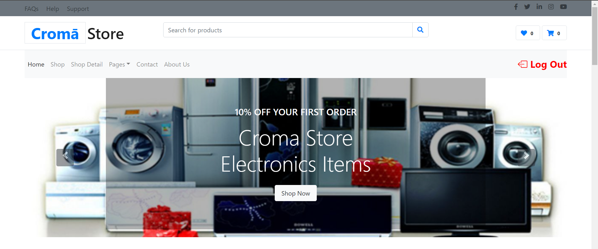

**Shop :**

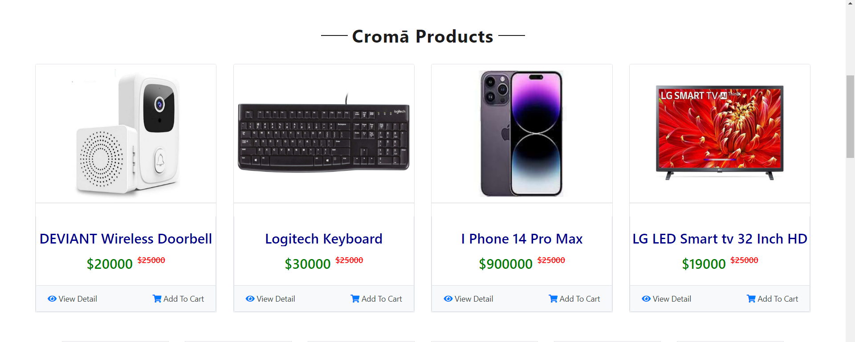

**Contact Us :**

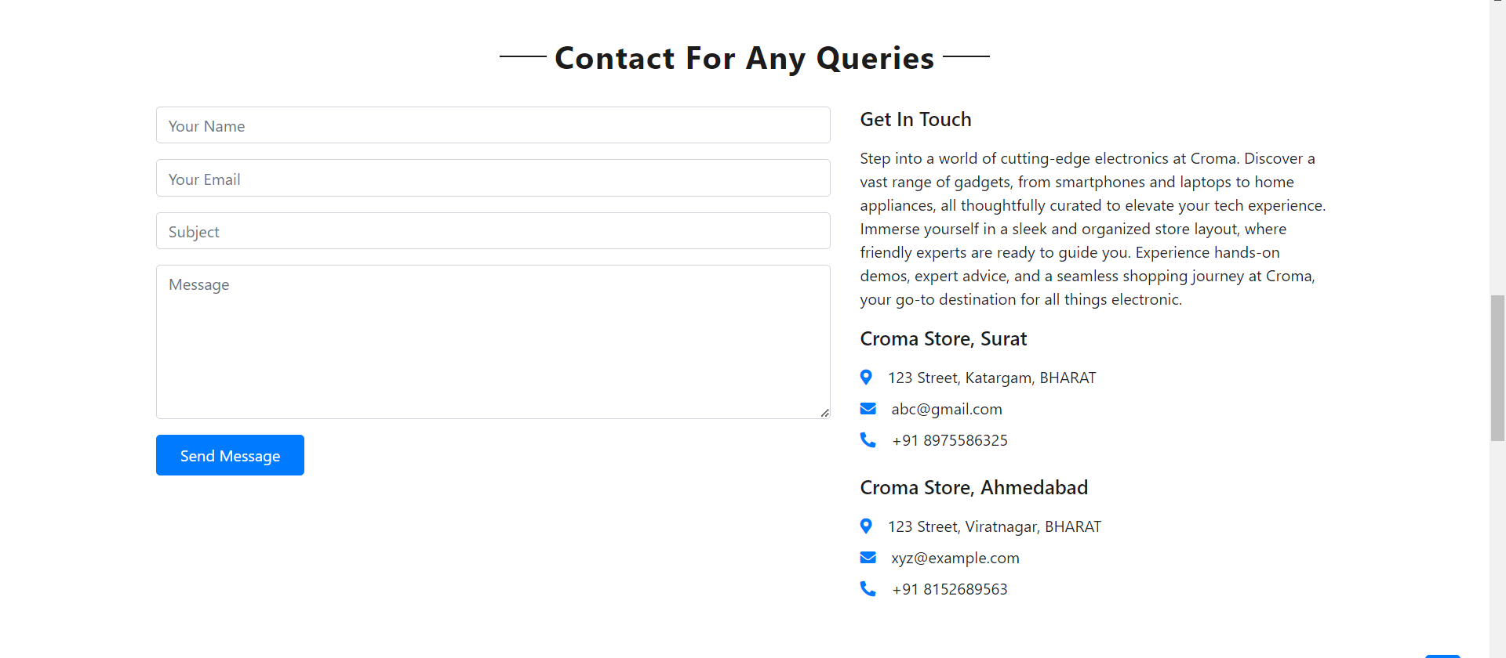

**About Us :**

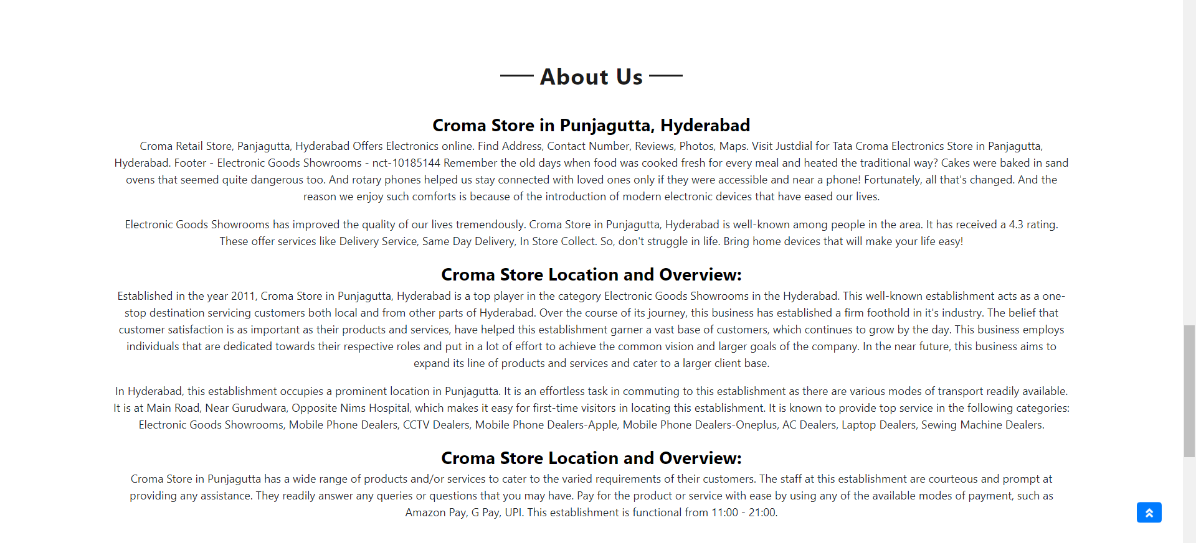

**User Registration :**

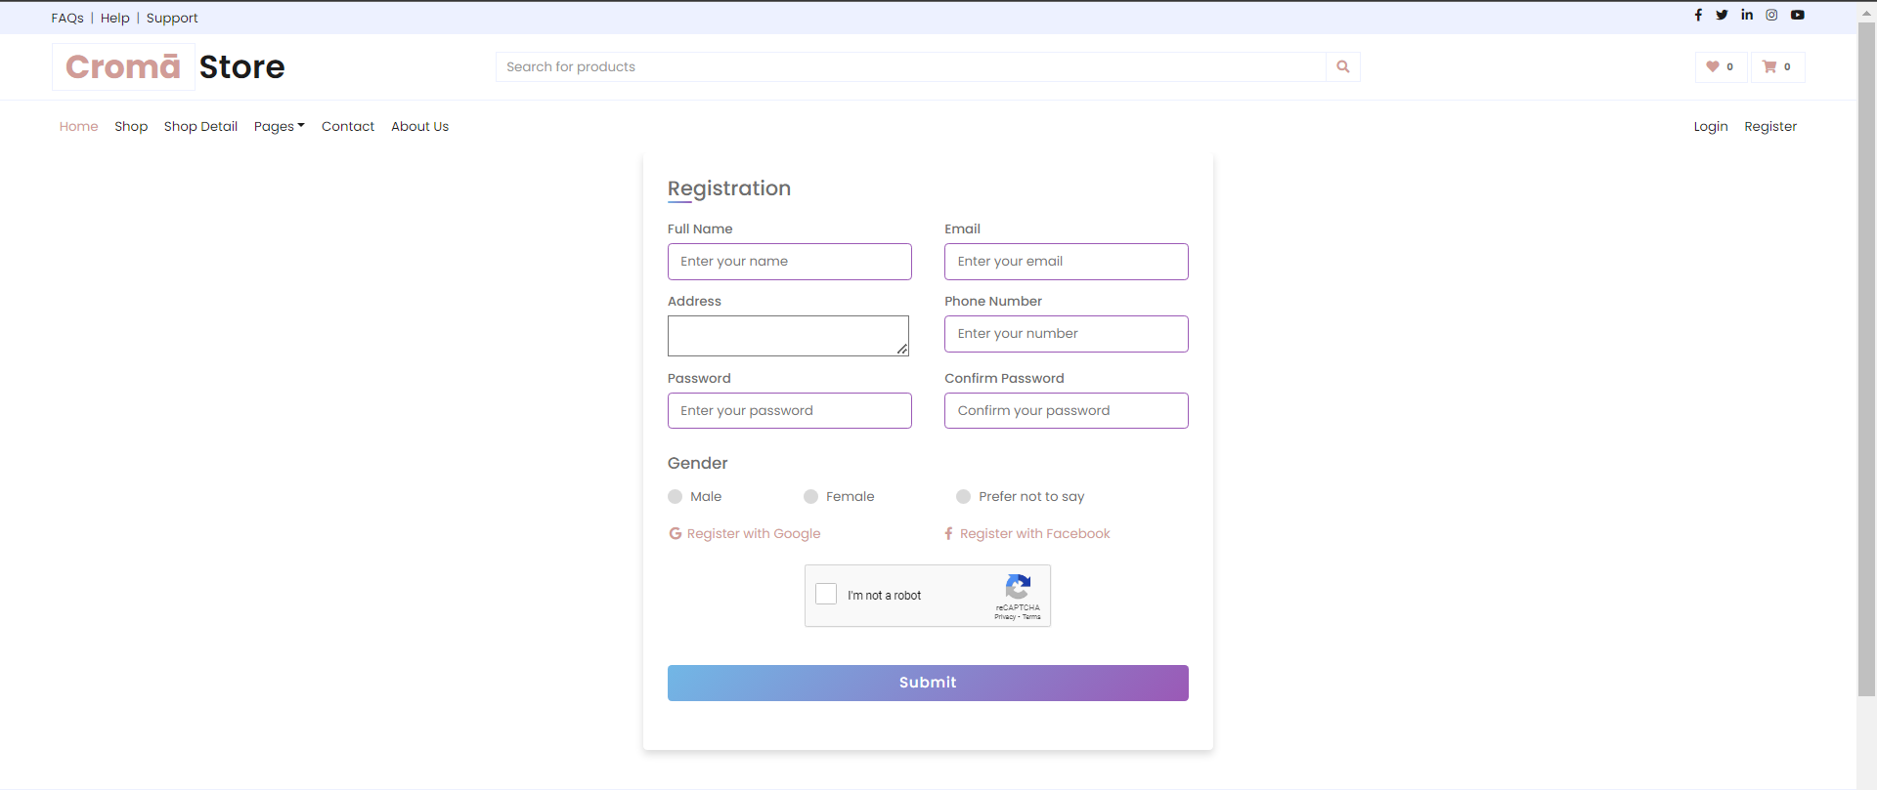

**User Login :**

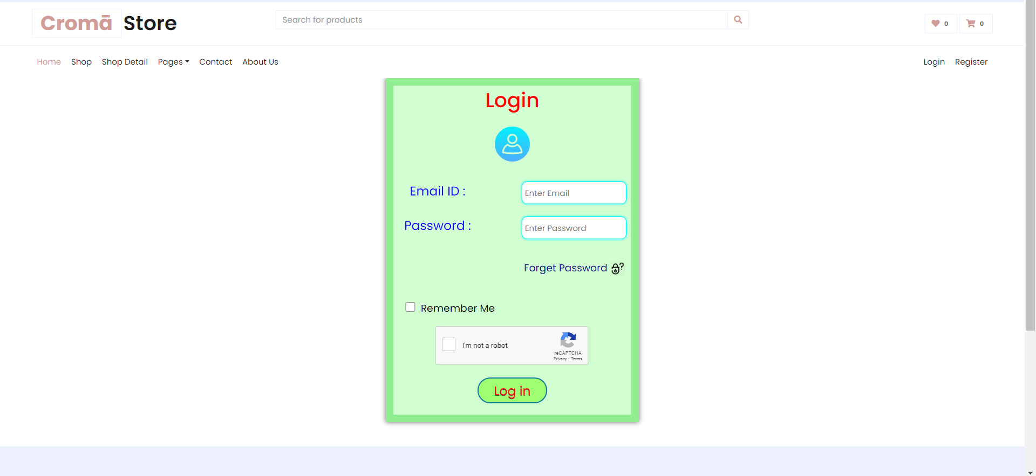

**Admin - Side :**

**Log in :**

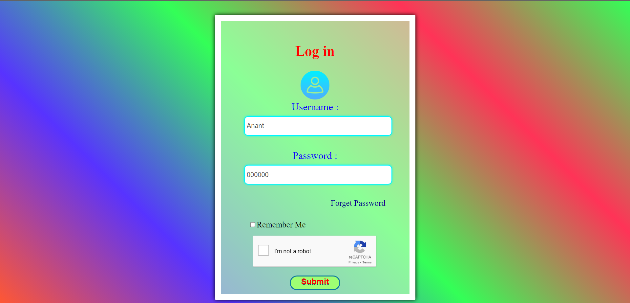

**After Login / Main.php :**

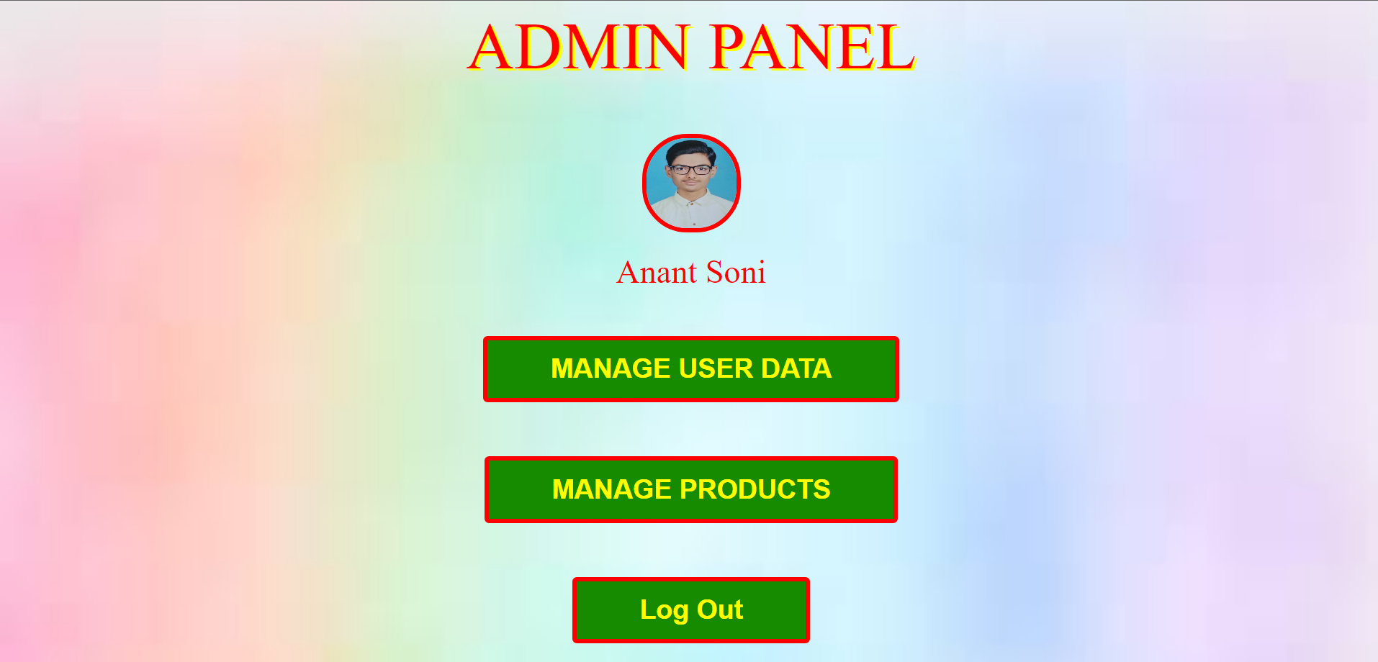

**Manage User Data :**

**Display Data :**

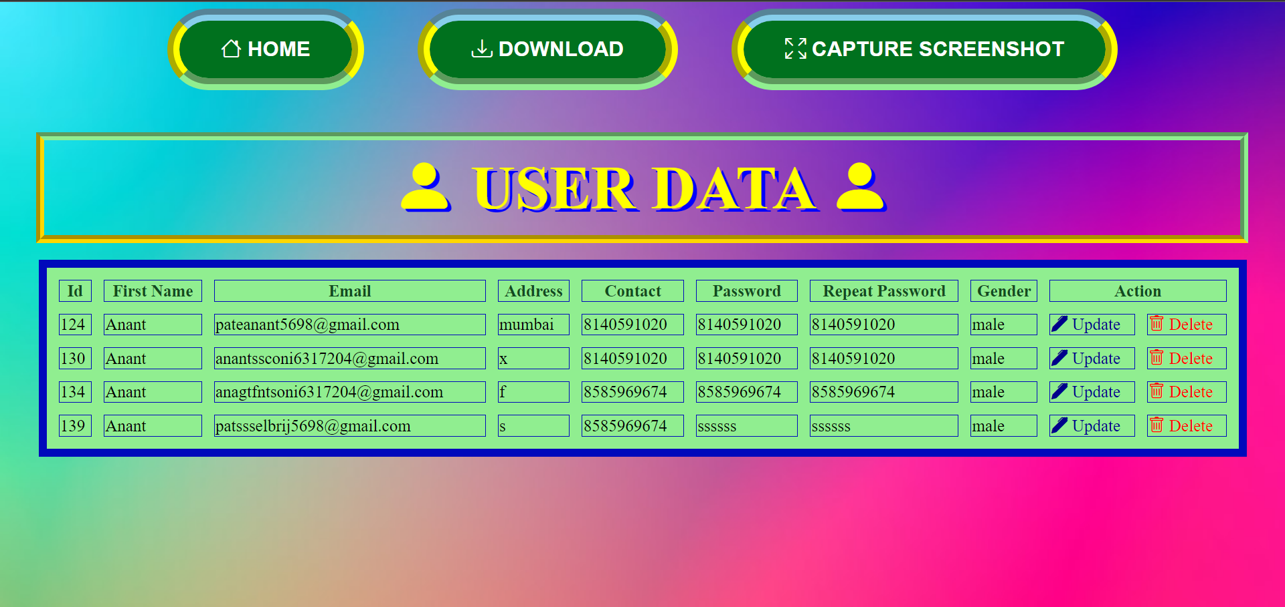

**Update Data :**

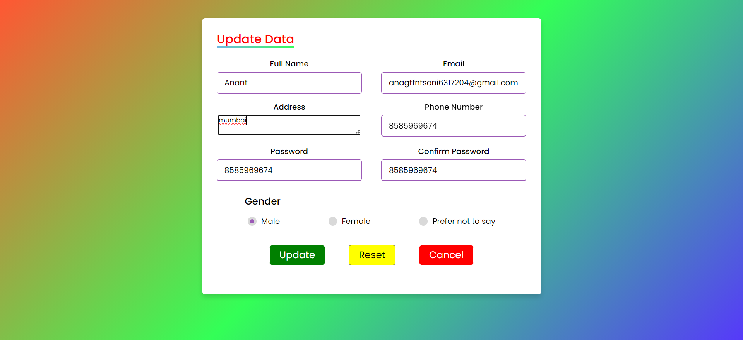

**Delete Data :**

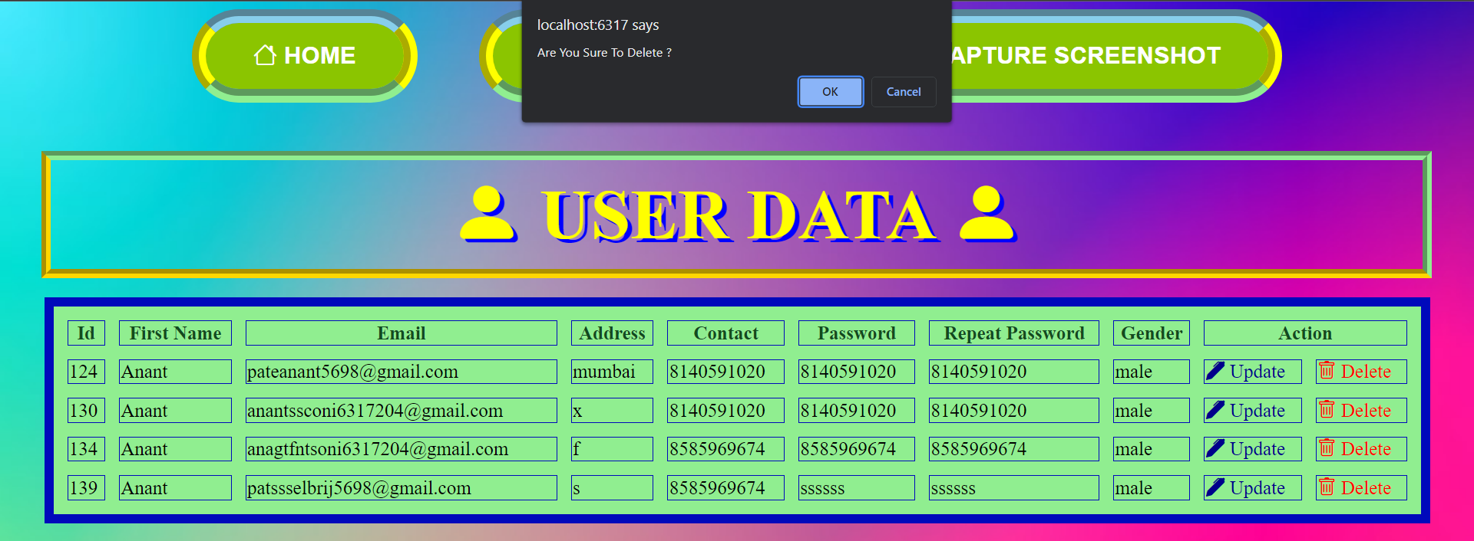

**6.4 Output Design :**

**Manage Products :**

**Add Products :**

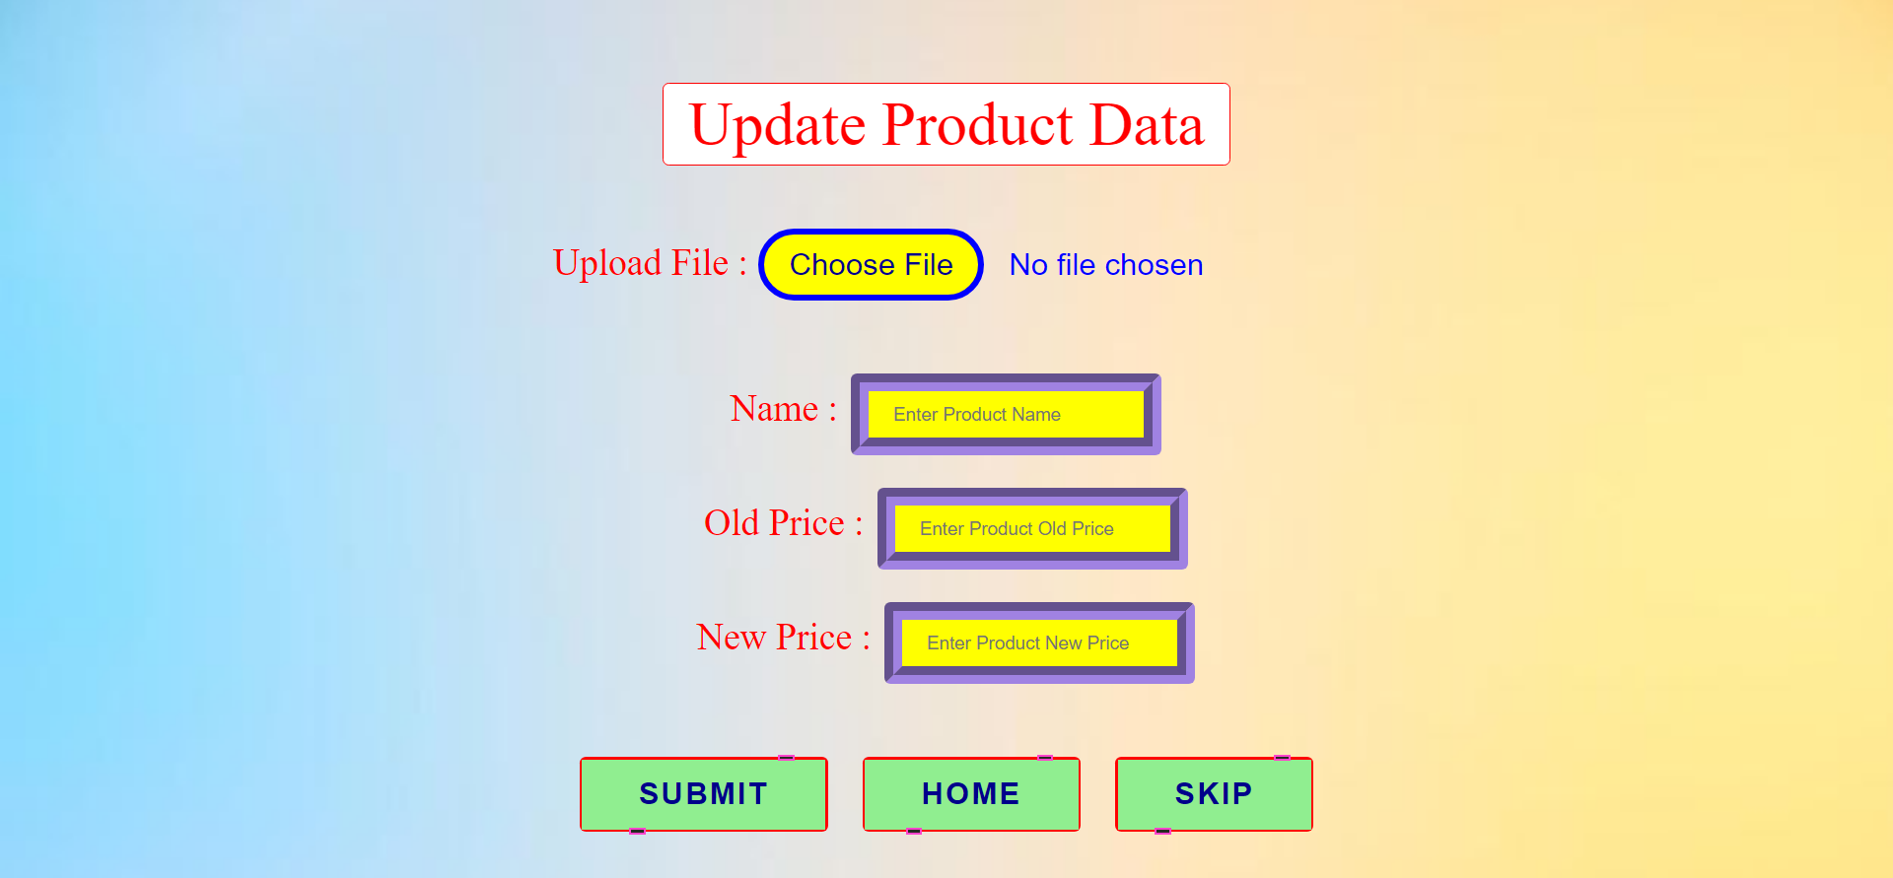

**Display Products :**

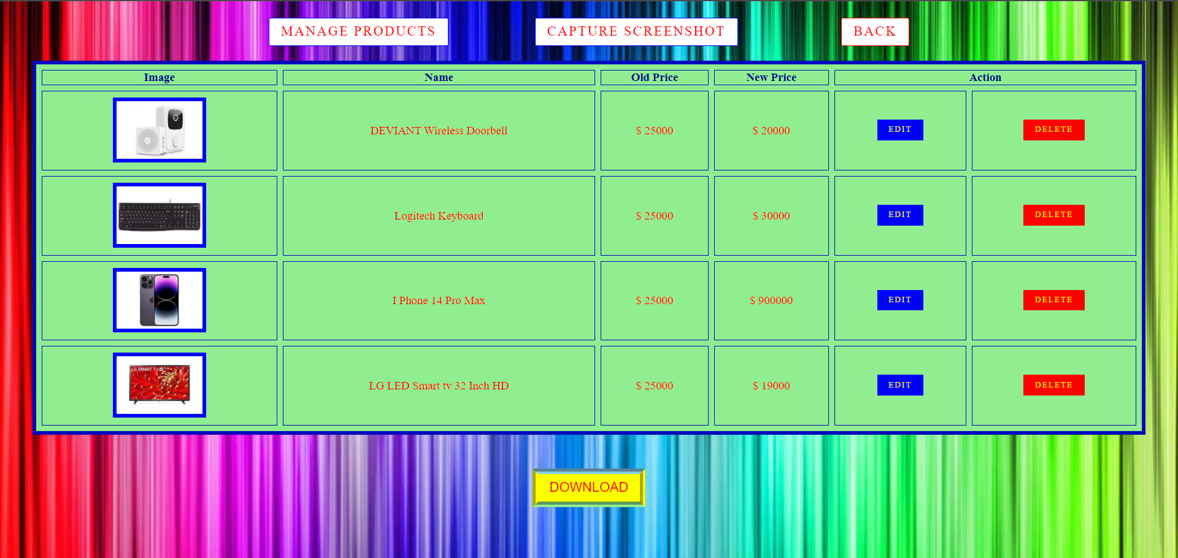

**Update Products :**

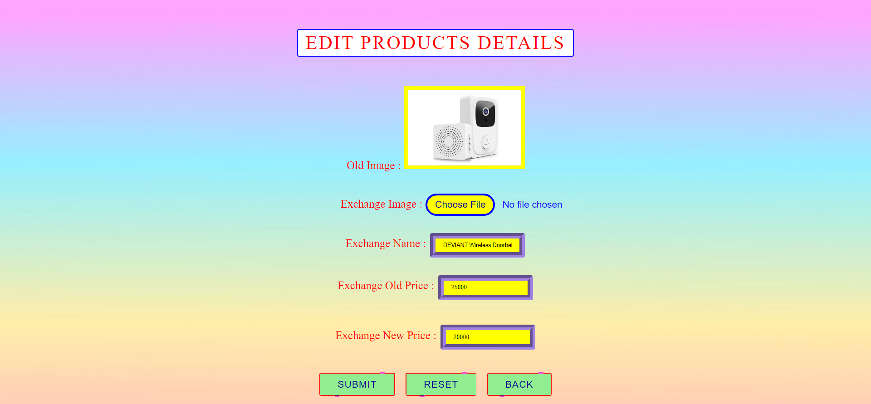

**Delete Products :**

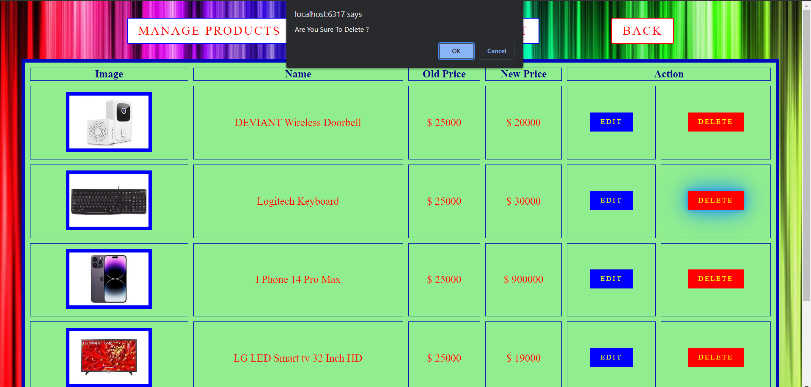

**7. Software Testing**

The testing process focuses on the logical intervals of the software ensuring that all statements have been tested and on functional interval is conducting tests to uncover errors and ensure that defined input will produce actual results that agree with the required results. Program level testing, modules level testing integrated and carried out.

Functional Testing:

* + All web pages work properly
  + All navigation work properly
  + MySQL database work proper
  + All Pages Design is perfact

Environment Testing :

* Browser – Internet Explorer/Chrome
* Internet explorer and chrome consider testing for environment
* Operability work properly
* Web server – IIS/Apache
* Database – SQL Server Management Studio
* OS – WINDOWS 11

**8.Limitations and Future Scope of Enhancements**

**Limitations:**

The Croma Store web application, like any web-based system, has its limitations that can impact its functionality and performance. One significant limitation is related to connectivity and accessibility. While the web application offers the convenience of online shopping, it relies on stable internet connections for both customers and the store's backend systems.. Ensuring full accessibility compliance can be challenging, and some users may face barriers in navigating or using the website.

**Scope:**

The future scope includes expand the technologies like HTML and PHP we can also add new technologies like Laravel, reactjs many more for improving the efficiency of the software.

The Croma Store system is the next generation address book which will provide these two basic services like portability, security.

The primary scope of the web application includes providing customers with a user-friendly and convenient online platform to browse, select, and purchase a diverse range of consumer electronics and home appliances.

* This project can be upgraded by adding more options such as product discounts and more admin operations.
* Updating Add to cart or payment option with properly security.
* Website can be upgraded by improving performance as per user feedback

**9. References**

<https://www.w3schools.com/html/default.asp>

<https://www.w3schools.com/css/default.asp>

<https://www.w3schools.com/js/default.asp>

<https://www.w3schools.com/php/default.asp>

<https://youtu.be/-lM-U8WK_Ko?si=1xQrs_CUT9RFgHFP>